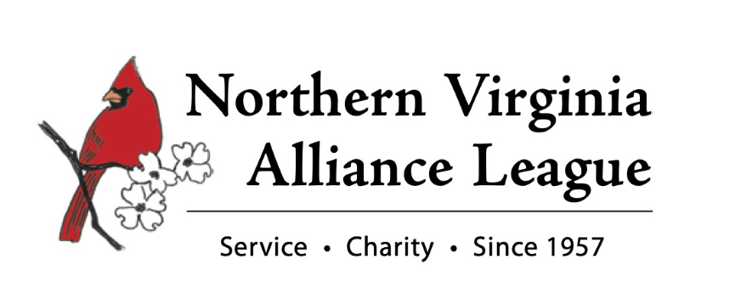
2022 Sponsor Contract

Sponsor Name: ___________________________________________________________________________
(As you wish it to appear in print)
Contact person: __________________________________________________________________________

Address: _____________________________________________________________________________

Phone: __________________Email: _______________________Website: ___________________________

Sponsors Levels

- Platinum $5,000
- Gold $2,500
- Silver $1,000
- Bronze $ 500
- Friends of NVAL $ 250

- Anonymous Gift: This gift is to remain anonymous and will not be listed in printed materials.
- I will not be using any allotted tickets; making the full sponsorship amount a tax donation.
- I am unable to be a Sponsor this year, but would like to make a tax-deductible donation in the amount of $___________ made payable to: Northern Virginia Alliance League
PO Box 5165, Arlington, VA 22205

- I prefer to pay by Credit Card: https://givebutter.com/2022HolidayLuncheon

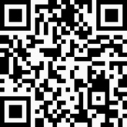 OR

Name_____________________________________________________________________________
Credit Card Number____________________________ Expiration Date__________ CVC_______
Billing Address_____________________________________________________________________

Northern Virginia Alliance League (NVAL) is a 501(c)(3) non-profit organization run by volunteers.
All donations are tax deductible to the full extent allowable by law.
Tax ID Number is #52-1284397
For more information about NVAL, please visit our website @nval-info.org or nvalinfo@gmail.com.

